EXPERIMENT NO:6
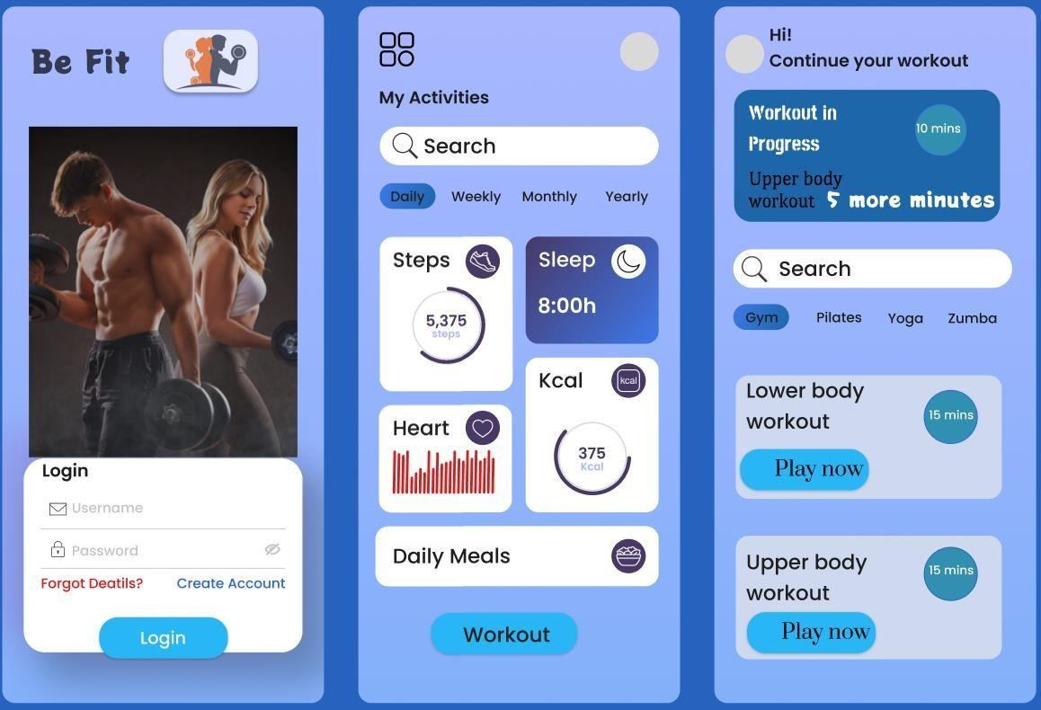
USER INTERFACE DESIGN
JAI SHURIYA
2407011200

RAD for Fitness App
RAD (Rapid Application Development) is a software development methodology that emphasizes quick development and iteration of prototypes over strict planning. It is ideal for a fitness app where user needs evolve (e.g., workouts, tracking, personalization).

Key Characteristics of RAD
- Focus on prototypes instead of heavy documentation
- User involvement throughout development
- Fast development cycles with frequent updates
- Reusable components (e.g., workout templates, UI modules)
- Best suited for UI/UX-intensive apps like fitness tracking apps

Phase 1: Requirements Planning
This phase defines project goals, system requirements, and user needs.

Identify Key Features Navigation:
  - Home Dashboard
  - Workout Plans
  - Exercise Library
  - Progress Tracking
  - Nutrition Tracker
  - Profile
  - Settings

User Actions:
  - Sign up / Login
  - Browse workouts
  - Start/track workouts
  - Log exercises (sets, reps, time)
  - Track calories and meals
  - View progress (weight, stats)
  - Set fitness goals
  - Receive notifications/reminders

Create a Requirements Document
- View personalized dashboard (daily activity, goals)
- Browse workout categories (strength, cardio, yoga, etc.)
- View exercises under each category
- View detailed exercise instructions (video/demo)
- Start and track a workout session
- Log sets, reps, duration, calories burned
- Track nutrition (meals, calories intake)

- View progress charts (weight, performance)
- Set and update fitness goals
- Receive workout reminders and notifications

Phase 2: User Design
Designers and users collaborate to create wireframes and prototypes.

Tools Used
  - Figma / Adobe XD (for UI/UX design)
  - Prototyping tools for interaction design

Wireframes Designed
  - Home Dashboard:
Shows daily summary (steps, calories, active minutes, goals progress)

Workout Plans:
Displays recommended or selected workout routines

Exercise Library:
Lists exercises categorized by muscle group or type

Exercise Details:
Shows instructions, images/videos, and tracking options

Progress Tracker:
Displays charts for weight, workouts completed, calories burned

Nutrition Tracker:
Allows users to log meals and track calorie intake

Profile:
Displays user info, goals, achievements

Additional Screens
  - Workout Session Screen:
Tracks ongoing workout (timer, sets, reps)

Goal Setting Screen:
Users set fitness targets (weight loss, muscle gain)

Notifications:
Reminders for workouts, hydration, meals

Design Considerations
  - Clean and motivating UI
  - Easy navigation (minimal taps)
  - Visual progress (graphs, badges)
  - Accessibility (clear fonts, icons)

Interaction & Navigation
  - Interactive buttons (Start Workout, Log Meal, etc.)
  - Swipe between workout steps
  - Real-time updates (progress tracking)
  - Use of reusable UI components (cards, charts, button

